# Story board for adding a new player and viewing over 100 wins report

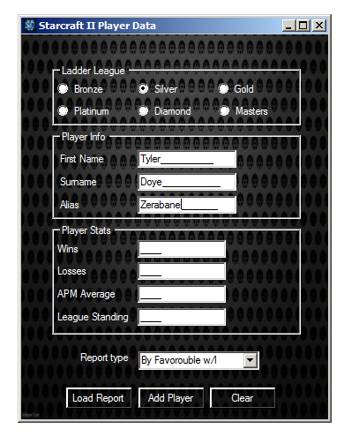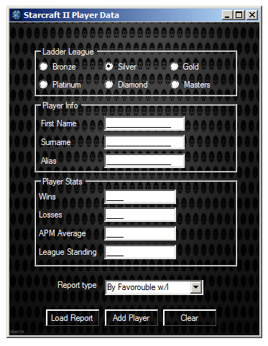1: user selects their current ladder league 2: user must enter their user details

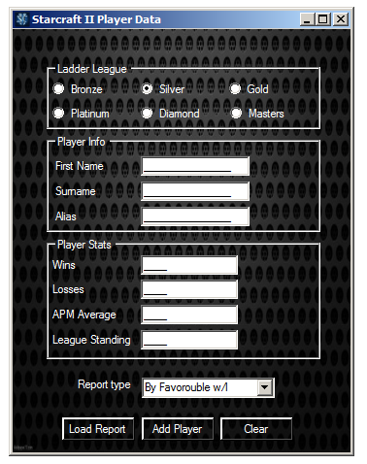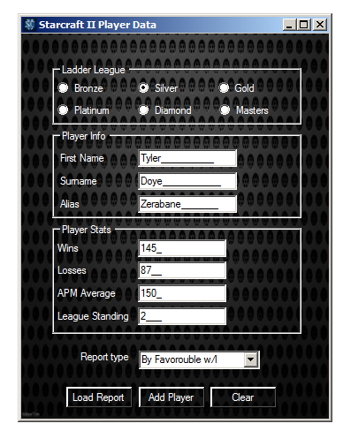3:User enters their statistics and clicks add player button 4: user clears the text fields by clicking clear button

5: user will select a report type, the report will 6: After clicking load report the selected

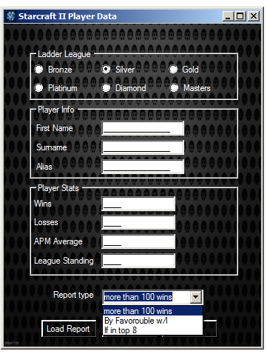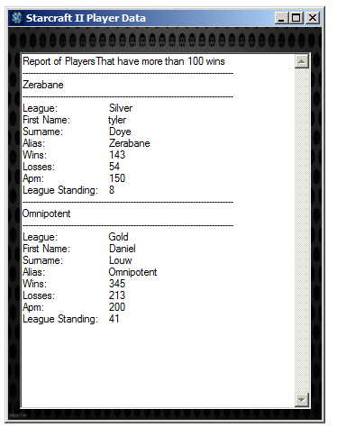filter the users to a certain criteria and report shows

clicks the load report button